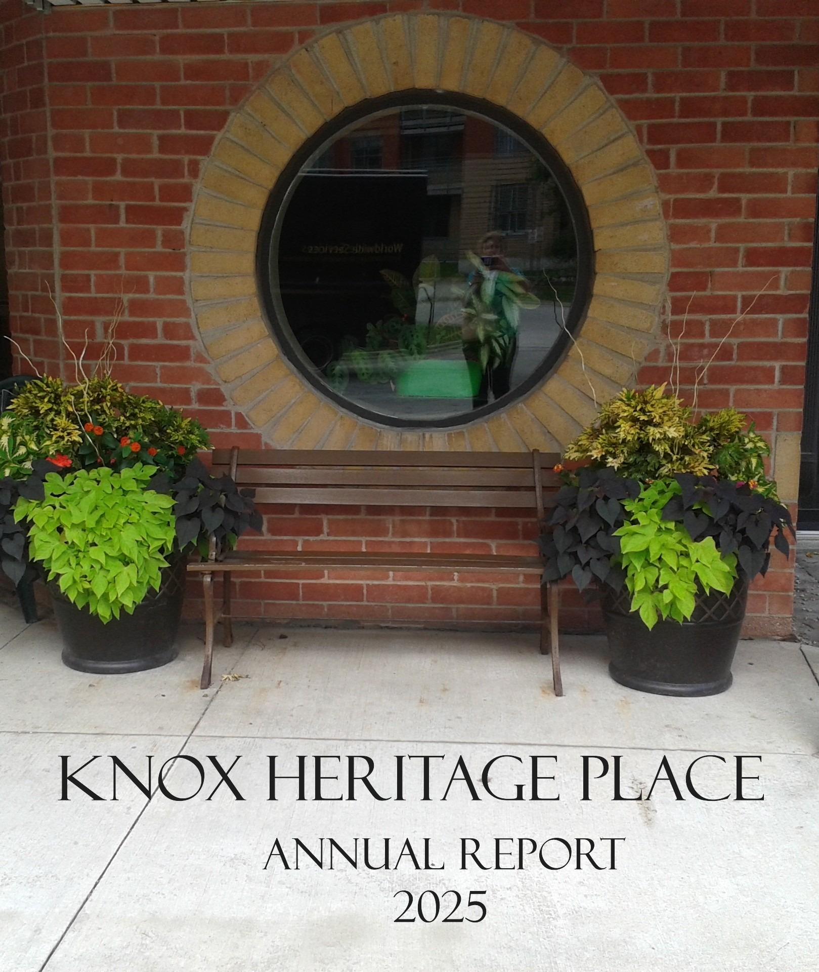

1. BUILDING DESCRIPTION l
2. CORPORATE INFORMATION III
3. ANNUAL MEETING AGENDA IV
4. ANNUAL GENERAL MEETING MINUTES APRIL 27, 2025 V
5. CHAIR'S REPORT X
6. TREASURER’S REPORT XI
7. AUDITED FINANCIAL STATEMENTS
INDEPENDENT AUDITOR’S REPORT 2
STATEMENT OF FINANCIAL POSITION 4
STATEMENT OF OPERATIONS AND CHANGES IN NET ASSETS 5
STATEMENT OF CASH FLOWS 6
NOTES TO FINANCIAL STATEMENTS 7-11
Knox Heritage Place is a non-denominational seniors’ apartment building situated in the River Oaks area of Oakville.

The philosophy behind the construction and operation of this building is to provide an environment that will contribute to the continued independence and autonomy for senior citizens. This is carried out through the structural design and decoration of the building along with the in-house activities engaged in by the seniors.

The structural design includes such prosthetic features as handrails in hallways which are both staggered and well lit, levered handles on doors, high placement of electric plug outlets and grab bars in the bathrooms. The front door entranceway has a sky-lit canopy along with variations in brickwork and roadwork to aid depth perception. Decoration features include seating by the elevators, and in the Richard Green Room there is high firm seating in sofas and chairs. Provisions have been made for wheelchair accessibility throughout the building. The facilities are intended to encourage interaction among the residents. The building has been placed beside a ravine within a garden setting to encourage enjoyment of nature.

There are 80 apartments on four floors. The building is serviced by two elevators.

Facilities on the ground floor include:

- The Richard Green Room, which is a common room for all residents. This room has a fireplace, piano, television and an informal seating arrangement. A kitchen off the common room allows this room to be used for informal dining for organized events.

- A laundry room with four washers and four dryers.

- A solarium with a door leading to the rear of the building where gardening enthusiasts have garden plots.

- A guestroom that is available for tenant emergencies or for lease at a minimal cost for visiting friends and family.

- Continued
Building Description Continued

The fourth-floor houses three activity rooms

- One large, skylight room used for art and crafts, bingo and exercise classes.
- A library/games room with cozy seating and a view of the lake.
- A tenant storage room housing ten large cage lockers and additional space for tenant bike storage.

Four units are designed as partially accessible through consideration in the kitchen and bathroom areas. Throughout these apartments, light switches are low and plugs are placed higher.

The ground floor apartments have small patios off the living room. A large patio with a barbecue for all the residents is located at the rear of the building overlooking the ravine. There is also a balcony on the second floor on the front of the building.

All apartments were upgraded in 2015 and have vinyl plank flooring in the kitchen, hallway and bathroom with carpeting in the living room and bedrooms. A refrigerator and stove are provided. The heating is electric, and individual thermostats are in the living room, bedroom and bathroom of each unit. Both elevators were fully updated with completion of the project in 2022.

The rents for the apartments are at the low end of the market rent for Oakville. For applicants who may have difficulty affording these rents, subsidies allow some qualifying tenants to pay an amount of rent geared to their income. There is a great demand for these subsidized units and only a percentage of the apartments can be subsidized. There is a waiting list for all units.

Residents are asked to show a willingness to participate in the development of this seniors’ citizen community.

Knox Heritage Place is managed by Knox Heritage Place Inc., a non-profit corporation with a volunteer board of directors. Knox Presbyterian Church makes no monetary contribution toward the upkeep of Knox Heritage Place; however, the members of the congregation do contribute as directors, in offering advice and moral support. An Administrator, Property Maintenance person and Recreation Coordinator are employed by the corporation.

KNOX HERITAGE PLACE INC.
CORPORATE INFORMATION

 | Chair |  | Richard Fortier
 | Treasurer |  | Rob Harvey
 | Secretary |  | Meghan Amm

DIRECTORS

 | Meghan Amm |  | Gary McBay
 | John Ferguson |  | Mike Moffatt
 | Richard Fortier |  | Donna Starkey
 | Rob Harvey |  | Dave Newton
 | Angus Kennedy |  | Fraser Sinclair
 | Howard Thomas
STAFF

 | Administrator |  | Melissa Zentner
 | Property Maintenance |  | Sinisa Slijepcevic
 | Recreation/Admin. Asst. |  | Rebecca Ruskoff
 | Security |  | Lorne Weller
 | Security |  | Bonnie Zicari
 | Security |  | Patrick Tackaberry
 | Security |  | Lorraine McCandlish

KNOX HERITAGE PLACE INC.
ANNUAL GENERAL MEETING APRIL 19, 2026

12:30 Light Lunch

1:00 Meeting with opening prayer

PROPOSED AGENDA

- Call to order

- Adoption of agenda

- Annual General Minutes April 27, 2025

- Report from the Board Chair

- Report from the Treasurer

- Approval of the Audited Financial Statements

- Appointment of Auditors for the 2026 fiscal year

- Election of Directors

- Other Business

- Meeting Termination

KNOX HERITAGE PLACE INC.

MINUTES OF THE ANNUAL GENERAL MEETING

SUNDAY, APRIL 27, 2025

The Annual General Meeting of Knox Heritage Place Inc. was held on Sunday, April 27, 2025, in the Green Room of Knox Heritage Place, 2191 Sixth Line, Oakville, Ontario.

MEMBERS PRESENT

Meghan Amm | Zosia Blackstone | Barbara Browne
Roma Browne | Warren Browne | John Ferguson
Richard Fortier | Molly Fraser | Gary Frazer
Luella Frazer | Rob Harvey | Angus Kennedy
Gary McBay | Ian Molyneaux | Dave Newton
Fraser Sinclair | Donna Starkey | Shona Thornton

Duncan Turnbull

STAFF

Melissa Zentner Rebecca Ruskoff

REGRETS

John Aitken | Margaret Aitken | Erwin Biener
Helen Biener | Dennis Camm | Heather Carey
Philip Carey | Hugh Cass | Diana Clarke
Charles Fraser | Stan Frazer | Mike Gillatt
Diane Hambleton | Peter Kaps | Pam Leonard
Archie McKenzie | Rosemary McKenzie | Mike Moffatt
Brian Murphy | Carl Nelson | Agatha Platiel
Richard Roberts | Clayton Shold | Don Tees
Lyn Turnbull | Brett White | Robert Whyte
Carol Wilkinson | Keith Wilkinson

The meeting was called to order at 1:05 pm by the Chair of the Board of Directors, Richard Fortier, and Donna Starkey gave the opening prayer.

Meghan Amm, acting as Secretary of the meeting, reported that notice of the meeting had been duly given to the members by email. A quorum was declared.

ADOPTION OF AGENDA:

MOTION: That the agenda be adopted.

Moved: Gary Frazer
Seconded: Molly Fraser
CARRIED

APPROVAL OF PREVIOUS MINUTES

MOTION: That the minutes of the previous Annual General Meeting on Sunday,
April 28, 2024, be approved.

Moved: Warren Browne
Seconded: Angus Kennedy
CARRIED

REPORTS

The Chair called attention to the Report of the Chair of the Board in the Annual Report. He wished to highlight the renovation of the Green Room kitchen, which was completed in Fall 2024. He noted that residents are thrilled with the new kitchen, and thanked Melissa and the Property Committee for their excellent work on the project.

Next, the Chair discussed Project 3.5, and the progress of the application to Canada Revenue Agency (CRA) for charitable status. He indicated that the application was filed on March 27, 2025. In response to a question from Warren Browne, the Chair stated that the standard CRA response time for these applications is 6-12 months.

MOTION: That the Chairman’s Report be adopted.

Moved: Warren Browne
Seconded: Phil Carey

CARRIED

FINANCIAL STATEMENTS:

Rob Harvey, Treasurer, presented the Treasurer’s Report and the Auditor’s Report on the Financial Statements. First, with respect to the Statement of Operation and Net Assets, Rob mentioned that KHP had a small operating deficit due to legal expenses, but this was offset by investment returns.

Rob stated that the Audit and Investment Committee of the KHP Board revised the Investment Policy Statement in July 2024. The new investment portfolio mix is conservative, both to preserve funds for capital improvements and to protect against expected market volatility in 2025.

Next, Rob outlined the creation of the Capital Reserve Fund for accounting purposes. This change means that KHP’s accounting practices will reflect our actual practice of having two separate accounts for operating activities and investments. Rob noted that KHP has budgeted approximately $600,000 over the next few years to upgrade the showers and bathrooms in resident units.

Finally, Rob thanked the members of the Audit and Investment Committee and Melissa for their outstanding work over the past year. He thanked Fraser Sinclair in particular for stepping in during Rob’s recovery from surgery. In response to a question from Warren Browne, Rob confirmed that KHP has proper offsite backup procedures for audit documentation.

MOTION: That the Treasurer’s Report be adopted.

Moved: Barbara Browne
Seconded: Ian Molyneaux

CARRIED

MOTION: That the Knox Heritage Place, Inc. audited financial statements for the fiscal year ended December 31, 2024, be approved.

Moved: Warren Browne
Seconded: Duncan Turnbull
CARRIED

APPOINTMENT OF AUDITORS:

MOTION: That BDO Canada LLP be appointed as the auditors of Knox Heritage Place, Inc. for the fiscal year ending December 31, 2025.

Moved: Ian Molyneaux
Seconded: Barbara Browne
CARRIED

ELECTION OF DIRECTORS:

The Chair noted that Angus Kennedy and Ian Molyneaux have reached their term limits as Board Members. Richard thanked Angus and Ian on behalf of the Members for their service to the Board.

The Chair recommended electing Angus for a third consecutive term. The KHP Property Committee would greatly benefit from Angus’ expertise for current and future capital projects.

MOTION: That Angus Kennedy be elected to serve as a Director of the Board for a third consecutive three-year term.

Moved: John Ferguson

Seconded: Gary McBay

CARRIED

OTHER BUSINESS:

Dave Newton called the membership’s attention to the future need for individual heat and cooling units throughout the building. Dave indicated that roof load for these units, as well as the building’s electrical wiring capacity, should be assessed. Rob responded that KHP planned to investigate these issues as part of the current heat pump pilot program.

Finally, there was a brief discussion regarding the membership list and how KHP could endeavour to recruit new members.

Termination of Meeting:

MOTION: That the meeting be terminated.

Moved: Angus Kennedy

Seconded: John Ferguson

CARRIED

The meeting terminated at 1:45 pm.

KNOX HERITAGE PLACE INC.
CHAIR’S REPORT

What are the hallmarks of Knox Heritage Place? A safe and affordable environment for our residents, stewardship of the grounds and facilities, and strong governance: These are what make Knox Heritage Place a great place to live and to call home.

To that end, I thank our Administrator, Maintenance Technician, and Activities Coordinator, Melissa, Sinisa, and Rebecca, along with our security tenants, for their constant dedication. They combine with our volunteer board of directors to make KHP a desirable and caring community for independent seniors here in Oakville.

While 2025 was a milestone year for KHP from a long-term governance standpoint, we nonetheless maintained focus on the day-to-day priorities of our residents. Again, this year, we partnered with the Oak Park Neighbourhood Center to assist residents in filing their income tax returns. We continue to offer the regular services of a registered visiting footcare nurse, along with free exercise classes, to enhance our residents' health and well-being close to home. KHP is also fortunate and thankful for communal garden plots and naturalized areas that provide residents a chance to appreciate and interact with nature.

In last year’s report I highlighted that, to enhance KHP’s long-term viability and restore its financial vitality, we would apply for charity registration. In October 2025, the Canada Revenue Agency registered KHP as a charity under the Income Tax Act. Charitable status is advantageous to KHP in many ways. It allows us to raise monies through donations, it offers flexibility in managing investments and provides certainty of income tax status. Most significantly, it also allows us to enter into reciprocal arrangements with other charities to share and transfer funds and resources. As such, we entered into an agreement with Knox Presbyterian Church which allowed the forgiveness of a $3.5 million note to the Church, to the mutual satisfaction of both parties.

Respectfully submitted,

Richard J. Fortier
President and Chair

KNOX HERITAGE PLACE INC.
TREASURER’S REPORT

As highlighted in the Chair’s Report, 2025 has been a very significant year for Knox Heritage Place (KHP) and we ended the year in a much stronger financial position. Here are the financial highlights of these changes along with excerpts from our BDO audited financial statements.
Operating Fund Results
The Operating Fund is used to support the day-to-day operations of Knox Heritage Place. Total revenues were $1,186,805 made up of rental income, rent subsidies and miscellaneous income. Total expenditures were $1,156,043 including staffing costs, amortization, mortgage, building maintenance and repairs, utilities, professional fees and property taxes. The total excess (deficiency) of revenues over expenditures was $30,762 for the year. See the Statement of Operations and Net Assets for the full breakdown.
Capital Fund
Investment income in 2025 was $229,304 which represents a total return on investment on the Capital Fund portfolio of 14.6%; see the Statement of Operations and Net Assets. This out-sized return on our conservative portfolio mix was achieved through high dividends and gains on preference shares as interest rates dropped, and from the dramatic increase in the price of gold in 2025. The Capital Fund is managed by BMO Nesbitt Burns. As shown in Note 2, as at December 31st, the total investments were $1,652,383 and the portfolio mix was as follows:
- Short Term Cash and GICs 32%
- Long Term GICs 11%
- Preference Shares 32%
- Canadian Equities 25%
During the year, $103,080 was transferred from the Capital Fund to the Operating Fund to pay for capital projects and improvements.
Forgiveness of Promissory Note
As described in Note 7, effective October 21, 2025, the Canada Revenue Agency registered KHP as a charity and this fulfilled the conditions for forgiveness of the $3.5 million promissory note and interest obligations by Knox Presbyterian Church, Oakville. As a result, our net assets (or equity) have increased dramatically from $43,239 to $3,895,270 over the year (see Statement of Financial Position). In this year’s audit, the organization is no longer deemed to have liquidity risk. That is the risk of encountering difficulties in meeting our obligations with financial liabilities, or in plain English, we now have sufficient equity to be financially resilient and have the wherewithal to fund future capital projects confidently from our investments.
Respectfully submitted,
Rob Harvey
Treasurer

